CLOUD COMPUTING LAB: WEEK 6

PES1201802127

Siddharth K Rao

1. **Work Queues**

**1a) SS of the docker compose output:**

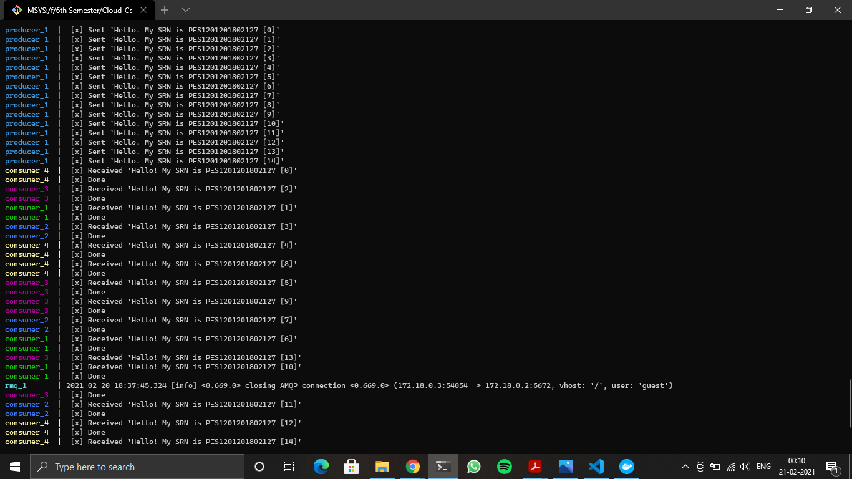

**1b) SS of the docker ps output:**

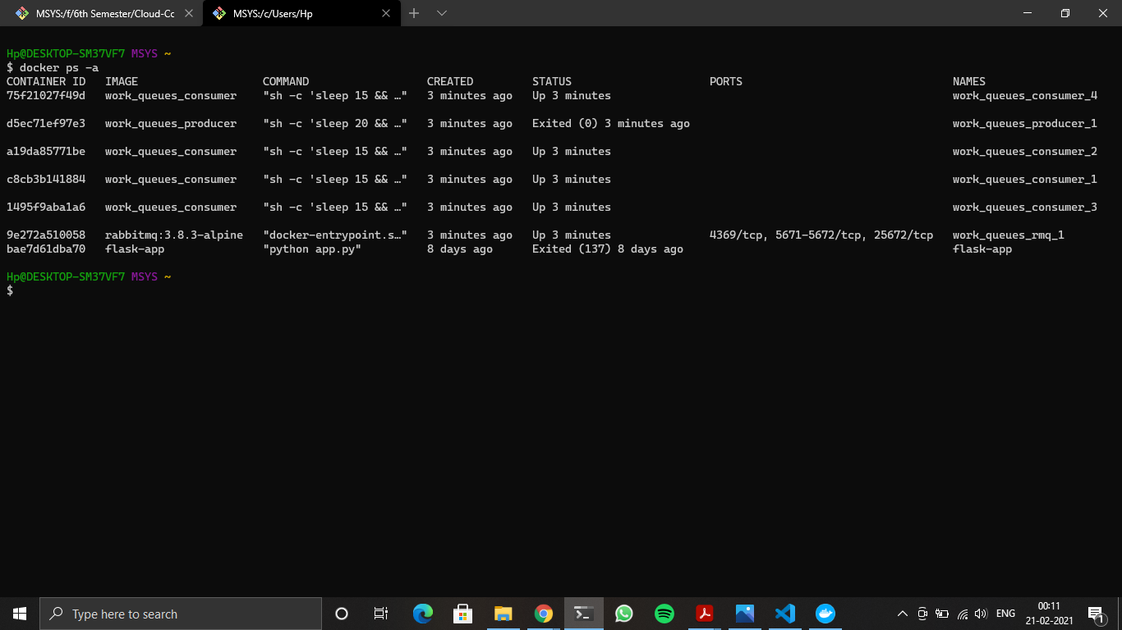

**1c) SS of the YAML File:**

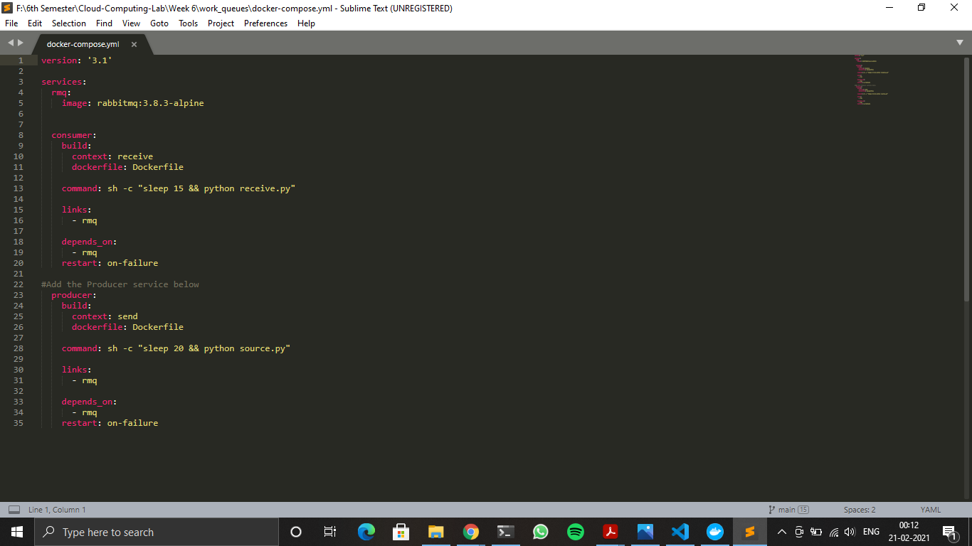

1. **Publish/Subscribe**

**2a) SS of the docker compose output:**

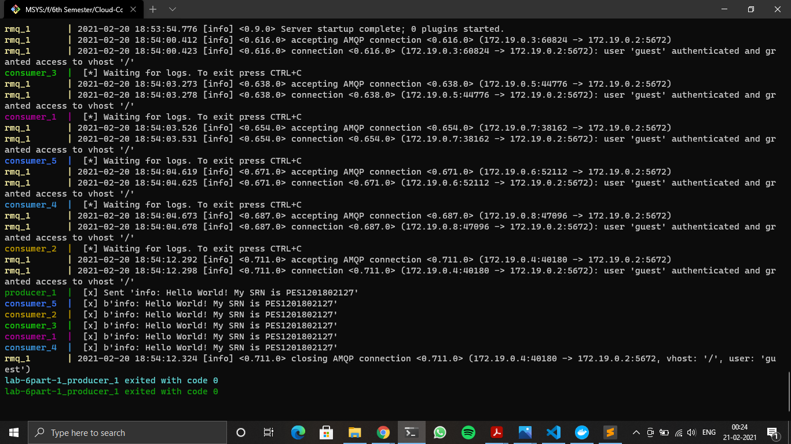

**2b) SS of the docker ps output:**

